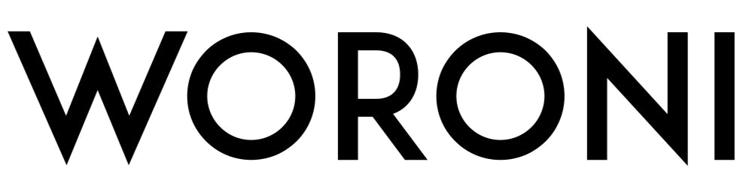

Australian National University Student Media

AGENDA: ANNUAL GENERAL MEETING (AGM) 2018

Tuesday 24 April, 5.00pm, HAG052

Item 1: Meeting Opens and Apologies

1.1 Acknowledgement of Country

1.2 Apologies

Item 2: Minutes from 2017 AGM [Reference A]

2.1 Motion: “To accept the 2017 AGM draft minutes.”

Item 3: Executive Reports

3.1 Editor-in-Chief’s report (James Atkinson) [Reference B]

3.2 Managing Editor’s report (Jonathan Tjandra) [Reference C]

Item 4: Discussion Items/Motions on Notice [Reference D]

4.1 2017 Audited Financial Statement [Reference E]
Motion: “That the duly audited annual financial statement be accepted.”

4.2 Provisional 2018 Annual Budget [Reference F]

Motion: “That the provisional 2017 annual budget be accepted.”

4.3 Honoraria Regulations [Reference G]

Motion: “That the Honoraria Regulations as attached in Item 4 [Reference G] be accepted.”

4.4. Editor Honoraria for Semester One 2018 Board of Editors

Motion: That the Association authorise the payment of honoraria to the members of the Board for Term One.

4.5 Art Editor Honoraria to Sophie Bear for filling a Casual Vacancy for Art Editor

Motion: Term One Art Editor Honoraria to Sophie Bear for filling a Casual Vacancy from the 6 February to the 29 March.

Item 5: Other Business
Item 6: Meeting Close

Expected Close of Meeting: 6:30pm

[Reference D]

Item 4: Discussion Items/Motions on Notice

4.1 2017 Audited Financial Statement

Motion: “That the duly audited annual financial statement be accepted.”

Moved: Jonathan Tjandra

Seconded: Mia Jessurun

[See Reference E – the 2017 annual financial statement – for supporting documentation for this motion.]

4.2 Provisional 2018 Annual Budget [Reference F]

Motion: “That the provisional 2018 annual budget be accepted.”

Moved: Jonathan Tjandra

Seconded: Mia Jessurun

[See Reference F – the 2018 provisional annual budget – for supporting documentation for this motion.]

4.3 Honoraria Regulations [Reference G]

Motion: “That the Honoraria Regulations as attached in Item 4 be accepted.”

[See Reference G – the Honoraria Procedure with suggested edits – for supporting documentation for this motion.]

Moved: Nathalie Rosales-Cheng
Seconded: Zoe Halstead

4.4 Editor Honoraria Term One 2018

Motion: That the Association authorise the payment of honoraria to the members of the Board – Mia Jessurun, Jonathan Tjandra, Max Koslowski, Zoe Halstead, James Atkinson, Linda Chen, Nathalie Rosales-Cheng. This amount should total AUD $1500 per Editor for work completed between 18 November 2017 to 29 March 2018.

Moved: Nathalie Rosales-Cheng
Seconded: Mia Jessurun

4.5 Art Editor Honoraria to Sophie Bear for filling a Casual Vacancy for Art Editor

Motion: That the Association authorise the payment of honoraria to the Art Editor, totalling $1500, with the split 100% to Sophie Bear and 0% for Zoe O’Leary-Cameron, for work completed 6 February to 29 March. Zoe O’Leary Cameron was on the Board between 16 July to 25 January and was replaced on the 6 February following a casual vacancy.

Moved: Nathalie Rosales-Cheng
Seconded: Jonathan Tjandra

